Minecraft Event Nomination Form

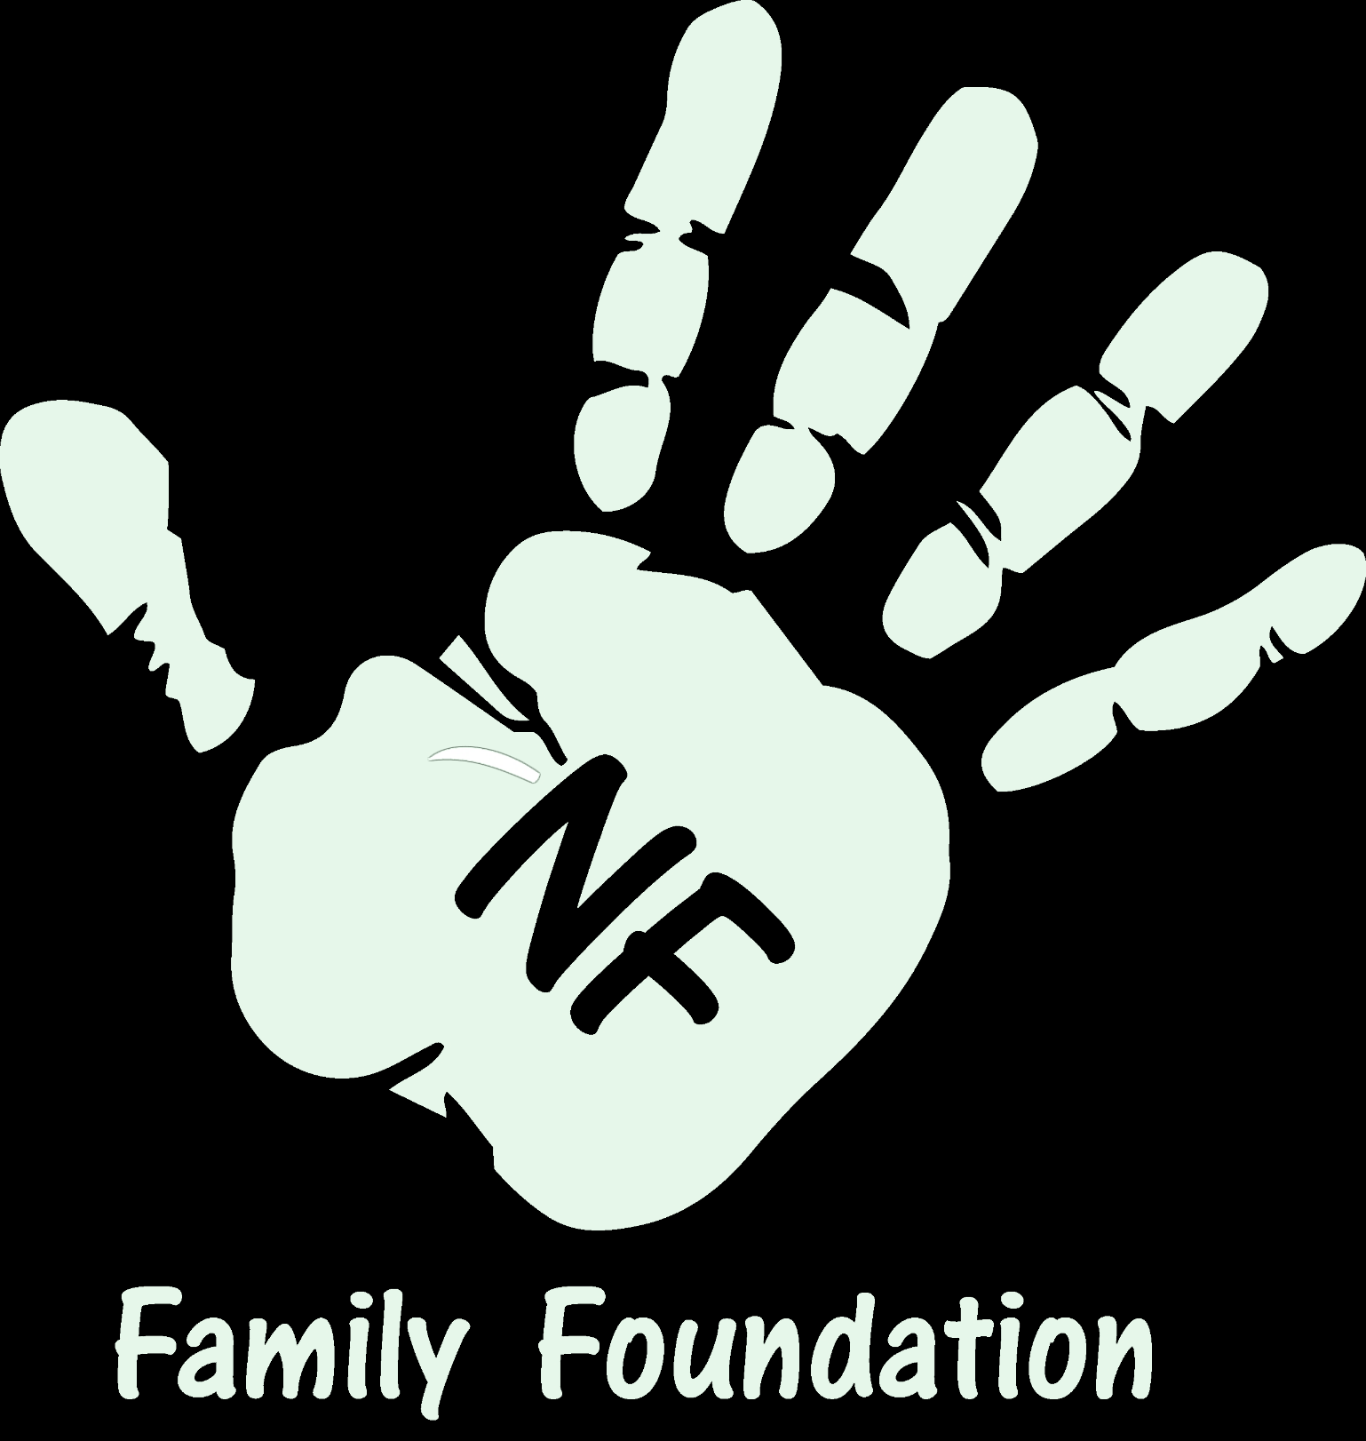
The NF Family Foundation is currently seeking a few local families in California who may have the chance to be involved in an amazing opportunity in conjunction with Mojang and Minecraft. The event is not yet confirmed but we would like to get an idea of the interest and begin the process of choosing families should this opportunity come to fruition. Details will not be released regarding the event unless your child/family is chosen to participate as it is a private event opportunity. Details may be made public nearer to the actual event.
Please complete this form by June 1, 2016 and email all supporting links or files to NFfamilyFoundation1@gmail.com (Include the child’s name in the email so they can be matched)
Forms that are not filled out correctly will be rejected. If the child is chosen to participate the NF Family Foundation will contact them with further details.
We are asking that families/nominees submit videos, pictures, handwritten letters etc to express how much they/the child love Minecraft and what it means to them including if they have any favorite YouTube Minecraft personalities. The more you are able to send the more information we have when choosing families to participate. Families will be chosen by a team of individuals including Minecraft YouTube personalities.
CHILD INFORMATION:
Name: _________________________________________________________________
Birthdate: ______________________________________________________________
Address: _______________________________________________________________
Diagnosis: ______________________________________________________________
Who do we contact regarding more information?: ______________________________
________________________________________________________________________
PARENT/FAMILY INFORMATION:
Mothers (Guardian) Name: ________________________________________________
Address: _______________________________________________________________
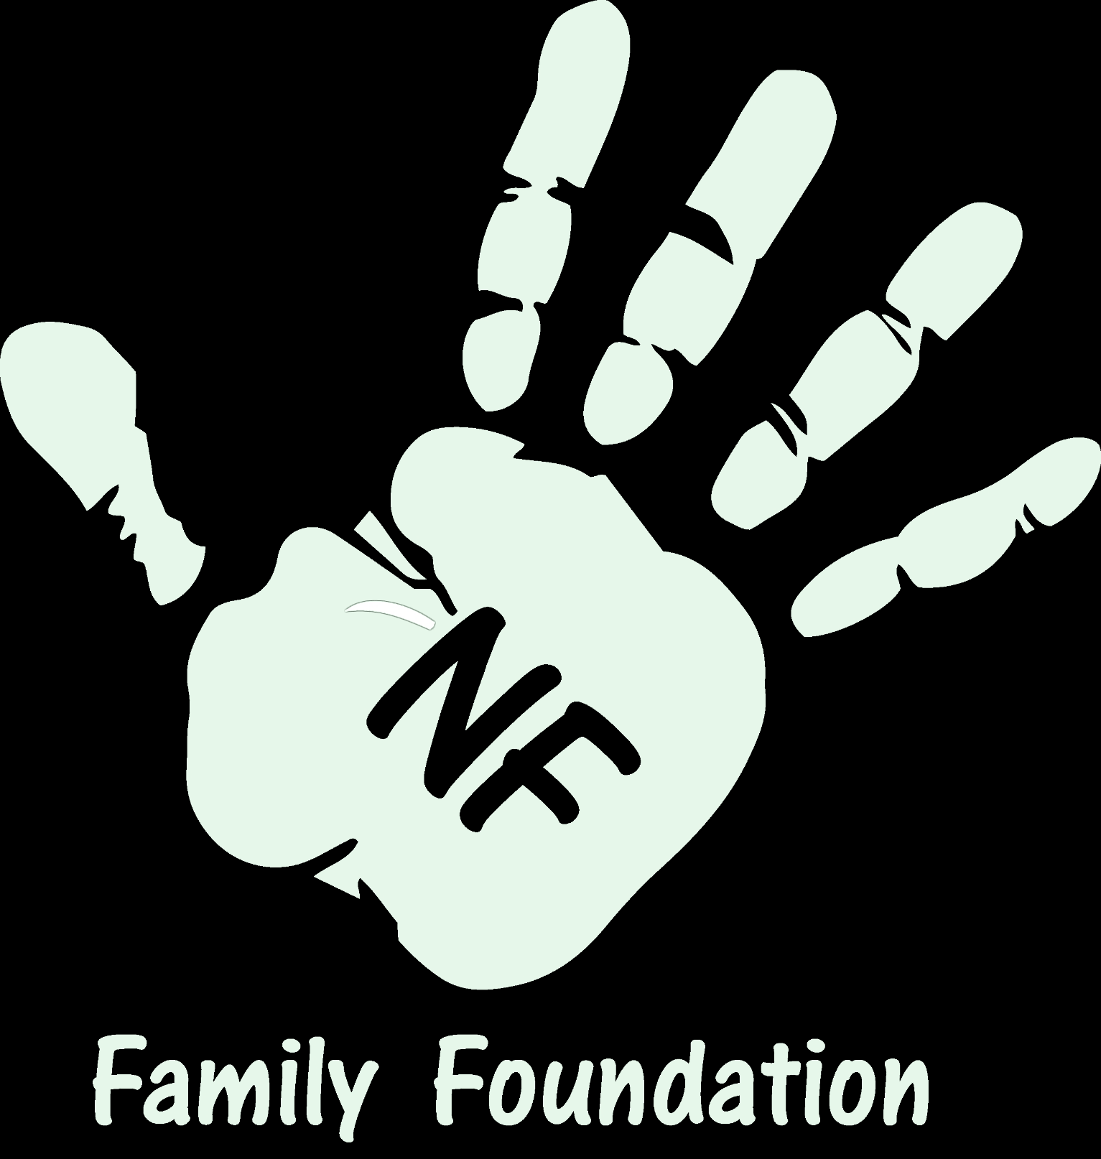
Phone Number: _____________________E-Mail: ______________________________
Father (Guardian) Name: __________________________________________________
Address: ______________________________________________________________
Phone Number: ___________________ E-Mail: ________________________________

Total number of immediate family members including adults and children: __________
Please List all members, their ages and relation to child being nominated for the event:
Name Relationship Age

Please circle the additional information formats you are submitting
Video / Pictures / Letter from Child / Supporting Letters from Family / Drawings / Others

